LOGIN, SCREENS & FILE TRANSFER (MAC)

1) Login to SHARCNET

Unix/Linux/OS X

From terminal:
$ ssh username@graham.computecanada.ca
Note: replace ‘username’ with your Sharcnet username

You will be prompted to enter your Compute Canada password.
username.computecanada.ca's password:
Enter your password and then hit enter.

Windows
https://www.sharcnet.ca/help/index.php/SSH

2) Available File Systems
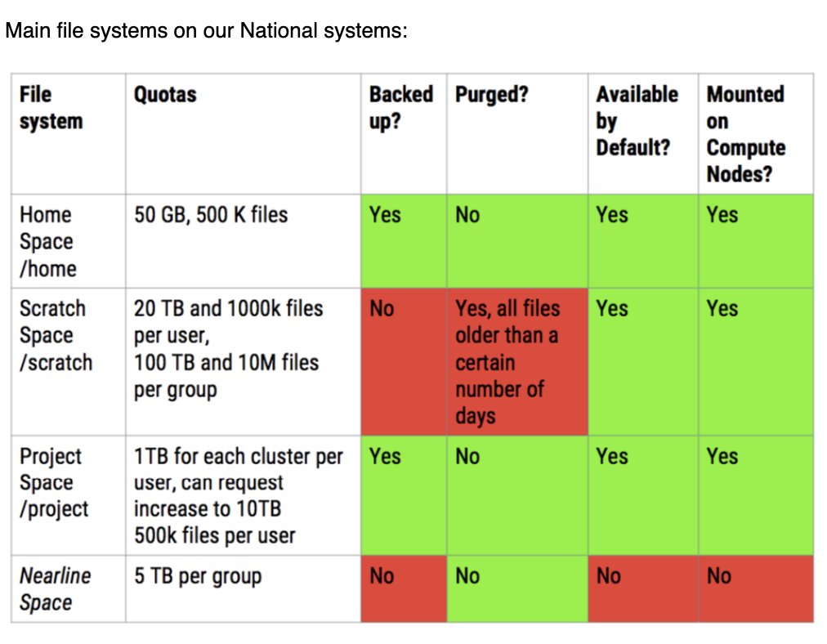

3) Using Screens
Screen or GNU Screen is a terminal multiplexer. This means that you can start a screen session and then open any number of windows (virtual terminals) inside that session. Processes running in Screen will continue to run when their window is not visible even if you get disconnected.

a) Screen Manual
To see all of the screen commands:
$ man screen

b) Starting Named Session
Named sessions are useful when you run multiple screen sessions. To create a named screen session, run the screen command with the following arguments:
$ screen -S sessionname
Note: replace ‘sessionname’ with a custom name of your choice

c) Detach from Linux Screen Session
- From inside the screen:
To detach manually (you are automatically detached if the connection is lost) press ctrl+a followed by d
- From outside the screen:
$ screen -d sessionID

d) Reattach to a Linux Screen
To find the session ID list from the current running screen sessions:
$ screen -ls
To restore a screen session, run the screen command with the following arguments:
$ screen -r sessionID
Note: replace ‘sessionID’ with the number before the session name that you chose

e) Terminate Linux Screen Session
- From inside the screen:
To terminate the current screen session: $ exit
- From outside the screen:
$ screen -X -S sessionID quit

4) Access File System Directories
Scratch Space
$ cd ~/scratch

Project Space
$ cd ~/projects/def-cdesouza/username

Nearline Space
$ cd ~/nearline/def-cdesouza/username

5) SCP File Transfer
Sharcnet to Local Machine
$ scp ccusername@graham.computecanada.ca:/home/username/projects/def-cdesouza/username/helloworld.txt /path_to_folder_on_local_machine/
Note: replace ‘username’ with your Sharcnet username

Local Machine to Sharcnet (use * to copy all files from the subdirectory)
$ scp /path_to_folder_on_local_machine/* username@graham.computecanada.ca:/home/username/projects/def-cdesouza/username/test/
Note: replace ‘username’ with your Sharcnet username

6) Compress Files in a Directory (for large files)
- Compress & Archive Files via –xz
Will produce a smaller compressed file (a "better compression ratio") but takes longer and uses more RAM while working.
$ cd foldername
$ cd ..
$ tar --create --xz --file foldername.tar.xz foldername
- Compress & Archive Files via –gzip
Does not typically compress as small, but may be used if you encounter difficulties due to insufficient memory or excessive run time during tar --create.
- $ cd foldername
$ cd ..
$ tar --create --gzip --file foldername.tar.gz foldername

6) Extract Files from .tar archive (for large files)
If there is no directory with the original name, it will be created. If a directory of that name exists and contains files of the same names as in the archive file, they will be overwritten.
- Extract .xz files
$ tar --extract --xz --file project1.tar.xz
- Extract .gz files
$ tar --extract --gzip --file project1.tar.gz

R, JOBS (SHARCNET)
https://docs.computecanada.ca/wiki/R
https://docs.computecanada.ca/wiki/Running_jobs#Examples_of_job_scripts
1) The R Interpreter

Load an R module
- There will be several versions available. To see a list of available versions:
$ module spider r
- To load a particular R module (i.e. version 4.0.0):
$ module load r/4.0.0

Execute an R script
To execute an R script non-interactively
$ Rscript filename.r

NOTE: Any calculations lasting more than two or three minutes should NOT be run on the login node. They should be run via the job scheduler.

2) Install R Packages

While running an interactive R session on the cluster’s login node
3) Jobscripts
a) See jobs in the queue:
- See a list of only your jobs in the queue:
$ sq
- See a list of all jobs in the system:
$ squeue

b) Submit a simple job that doesn’t involve any R script files.
- Create a job script file
  - Use an editor of your choice to create the file. This example uses nano.
$ nano jobscriptname.sh
  - Save the file via CTRL+X, then Y, then ENTER
  - Example of a simple job script (jobscriptname.sh)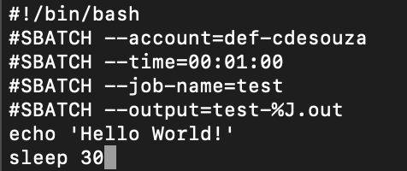
- Submit job:
$ sbatch jobscriptname.sh

c) Submit a simple job that involves an R script file.
- Create a simple R script file
Example of a simple R script (sample.R)
- Create a job script file (jobscriptname.sh) that will execute the R script (sample.R)
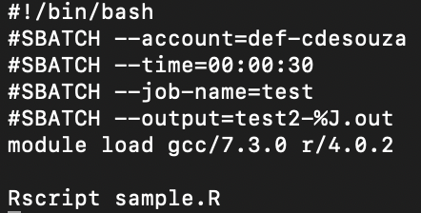
- Submit job:
- $ sbatch jobscriptname.sh

Sample job script
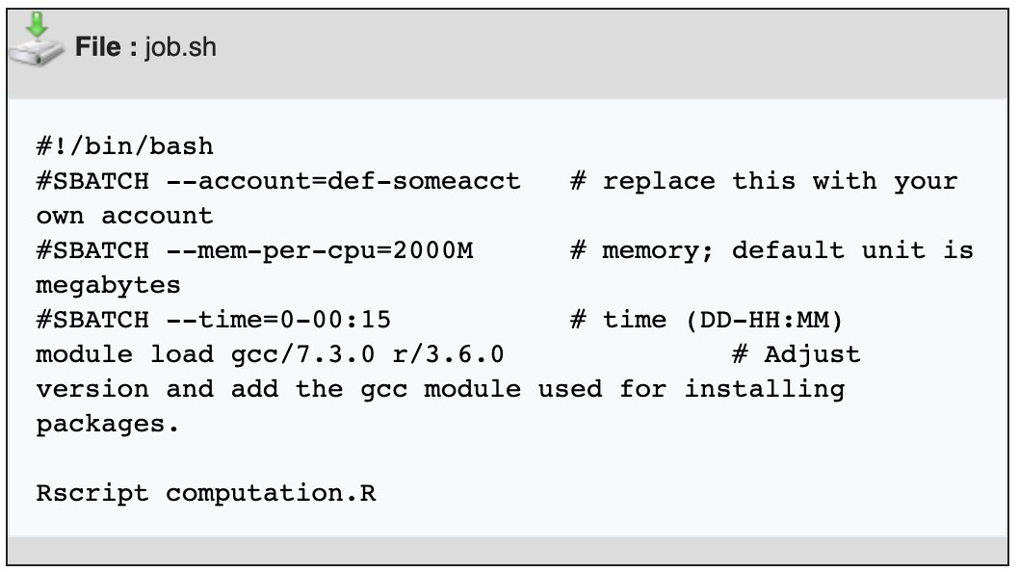

R Library & Packages
1) Create Personal R Library
- Log on to Graham.
- Navigate to your project folder.
$ cd ~/projects/def-cdesouza/username
- Load R module. Note: install all packages under R version "4.0.0":
$ module load r/4.0.0
- Type R to run R. Then type .libPaths() to check your R library directory.
$ R
> .libPaths()
- Create a personal library to load required packages when submitting a job on Graham.
$ mkdir ~/projects/def-cdesouza/username/Rlibs
- Create a .Renviron file in your home directory
$ cd ~/projects/def-cdesouza/username
$ nano .Renviron
- Add the following line to the .Renviron file:
R_LIBS_USER=~/projects/def-cdesouza/username/Rlibs
- Type R to run R. Then type .libPaths() to check if your R library directory has been changed.
$ R
> .libPaths()
2) Install R Packages
You can now install R packages by either downloading the package, placing it in your "R_local" directory and executing the following at the system command-line (not from within R):
% R CMD INSTALL ./name_of_downloaded.package
Most packages allow you to install packages directly from within R. For example, the statnet package instructs you to install using the following command from within R:
> install.packages("updatestatnet",dependencies=TRUE,contriburl="http://cran.us.r-project.org")
To install from CRAN use:
$ R
> install.packages("packagename")

3) Check if R package is Installed
If package abc is installed under one of the libPath locations. Either TRUE or FALSE will be returned.
[roberpj@orc-login1:~] R
> .libPaths()
[1] "/gwork/roberpj/R_local/el6"
[2] "/opt/sharcnet/r/3.2.3/lib64/R/library"
> "abc" %in% rownames(installed.packages())
[1] TRUE
Removing the package then checking will result in FALSE being returned:
> remove.packages(c("gsl"),lib=file.path("/gwork/roberpj/R_local/el6"))
> "gsl" %in% rownames(installed.packages())
[1] FALSE

3) List All Installed R Package Versions
> ip <- as.data.frame(installed.packages()[,c(1,3:4)]);rownames(ip) <- NULL;
> ip <- ip[is.na(ip$Priority),1:2,drop=FALSE];print(ip, row.names=FALSE);
Package Version
assertthat 0.2.0
BH 1.66.0-1
bindr 0.1
bindrcpp 0.2
bitops 1.0-6
BradleyTerry2 1.0-8
brglm 0.6.1
broom 0.4.3
caret 6.0-78
caTools 1.17.1
CRAN:
http://lib.stat.cmu.edu/R/CRAN/
R Packages: A Beginner's Guide:
https://www.datacamp.com/community/tutorials/r-packages-guide

Required Packages
Install BiocManager
The current release of Bioconductor is version 3.12; it works with R version 4.0.3. Users of older R and Bioconductor must update their installation to take advantage of new features and to access packages that have been added to Bioconductor since the last release.
if (!requireNamespace("BiocManager", quietly = TRUE))
install.packages("BiocManager")
BiocManager::install(version = "3.12")

Install SC3
To install this package, start R (version "4.0.0") and enter:
if (!requireNamespace("BiocManager", quietly = TRUE))
install.packages("BiocManager")
BiocManager::install("SC3")

Install M3C
To install this package, start R (version "4.0.0") and enter:
if (!requireNamespace("BiocManager", quietly = TRUE))
install.packages("BiocManager")
BiocManager::install("M3C")

Install Scater
To install this package, start R (version "4.0.0") and enter:
if (!requireNamespace("BiocManager", quietly = TRUE))
install.packages("BiocManager")
BiocManager::install("scater")

Install Seurat
To install this package, start R (version "4.0.0") and enter:
install.packages('Seurat')
Mounting a Remote File System

1) Download and install macFuse and SSHFS from https://osxfuse.github.io/

2) Create a mount folder on your local device
$ mkdir /mount/path/sharcnet

3) Mount a remote directory from Sharcnet
$ sshfs username@graham.computecanada.ca:/home/username/projects/def-cdesouza/username /your/local/mount/path

4) Unmount folder on your local device
$ umount /mount/path/sharcnet

Installing Clustering Methods
1) BackSPIN (Python package)
- Create a virtual environment:
The tool virtualenv allows users to create virtual environments within which you can easily install Python packages. These environments allow one to install many versions of the same package, for example, or to compartmentalize a Python installation according to the needs of a specific project. It is recommended that you create your Python virtual environment(s) in your home directory.
To create a virtual environment, ensure you have selected a Python version with module load python.
$ module load python/3.6
Then enter the following command, where ENV is the name of the empty directory containing your environment:
$ virtualenv --no-download ~/ENV
Once the virtual environment has been created, it must be activated:
$ source ~/ENV/bin/activate
Upgrade pip in the environment:
$ pip install --no-index --upgrade pip
To exit the virtual environment, simply enter the command deactivate:
$ deactivate

- Install Backspin Package (https://github.com/linnarsson-lab/BackSPIN)
Load the Python interpreter:
$ module load python/3.6
Activate the virtual environment, previously created using the virtualenv command:
$ source ~/ENV/bin/activate
Install the latest stable version of Numpy:
$ pip install numpy --no-index
Install backspin
$ pip install backspinpy

- Run Backspin
Run directly using your command line tool and the sample dataset provided (oligos.cef) on github.
$ backspin -i oligos.cef -o oligos_clustered.cef -f 500 -v

- Note: BackSPIN takes input in CEF format and produces an annotated CEF file as output.

